**THE TITLE OF THE ARTICLE IS SPECIFIC, EFFECTIVE, CLEAR AND NO MORE THAN 15 WORDS. (FONT TIMES NEW ROMAN 16PT, BOLD, LEFT, SPACE 1). AVOID LISTING RESEARCH LOCATIONS, REGULATORY NAMES, AND ABBREVIATIONS**

Author Name 1 (no title, font Times New Roman 14pt, Left, Space 1)

1 Institution/affiliation, Country (font Times New Roman 10pt, Left, Space 1)

*Corresponding Author: (font Times New Roman 10pt, Left, Space 1)

**ABSTRACT**

Abstracts in english written a maximum of 250 words. The abstract explicitly contains: brief background (one sentence only, may not exist), research objectives, research methods, and important research findings. Abstract written 1 (one) paragraph (font Times New Roman 10pt, Justify, Space 1).

**Keywords:** Consists of 3 to 5 words. Written in alphabetical order. Between keywords separated by colons (,). Excludes regulatory name and institution name

**INTRODUCTION**

The introduction contains background, theoretical studies, problems, gap analysis, novelty of research results (state of the art), and ends with research objectives. Gap analysis contains the gap between das sollen and das sein. The novelty of research results (state of the art) contains a description of research studies with previous research (literature review).

The submitted article is original and has never been published anywhere. Articles that have been accepted and have gone through a review process, will be published gradually through the Open Journal System (OJS).

The writing format uses a single-column format with Times New Roman letters 12, space 1.15, Justify, A4 paper (210 x 297 mm), left, top, right, and bottom margins of 2.5 cm each. Manuscripts are written between 4000 to 7000 words.

**METHOD**

The method must contain the research design, research subject, instrumen, data collection procedures, and data analysis. Include a picture to explain the method used.

**RESULTS AND DISCUSSION**

The Research Results and Discussion contains a description of the analysis of research results to provide answers / solutions to research problems.  If there are details in accordance with the problems discussed, you can use the writing of sub-chapters as below.

**Subchapter (Times New Roman 12, Bold, font format: Capitalize Case)**

 In the Subchapter, avoid using dot points, dedication, or numbering as follows:

      a.    ....

      b.    ....

      c.    ....

It should be written following the following sentences: a. ....; b. ...., and c. ....

Manuscripts are written in the form of essays, so there is no numeric or alphabetical format separating between chapters / sections, or to mark new chapters / sections.   Tables and figures / graphs are only included in the discussion.  Tables are created only with horizontal lines.

The results of the study are reported in the form of a table, then the following format is used.

1. The title is written left-aligned above the table with Times New Roman Bold font 11 pt.
2. Fill the table using Times New Roman font 11 pt, single spaced.
3. The contents of the table should be referenced in paragraphs

**Table 1.     Correct Table Example**

|  |  |  |
| --- | --- | --- |
| Variable | Subvariables | Score |
| Creativeness | Figural | 80 |
|  | Verbal | 90 |

If the findings are reported in the form of images, then the following format  is used.

1. The title is written left-aligned  below the  image in Times New Roman Bold 12 pt font.
2. The color of the image is made in black and white.
3. The content of the image should be referenced in paragraphs

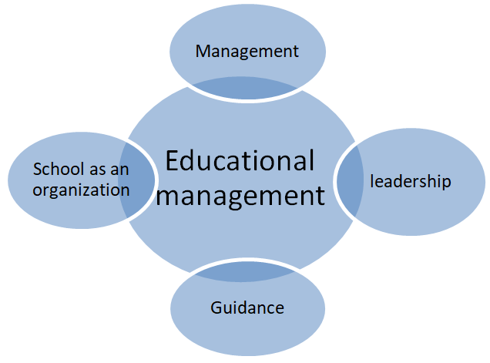

**Figure 1. Examples of Correct Images**

The discussion examines the results of research in relation to   theory as referred to in the Introduction.

# CONCLUSION

The conclusion is a short answer to the problem discussed. Conclusions are not made points, but described in 1 (one) paragraph

**REFERENCES**

The references should be written in the APA Style citation style, with 1 space spacing, Times New Roman font 12pt. Please use the Reference Manager application (Mendeley and Zotero) as the example below.

**Books:**

Anderson, D.W., Vault, V.D. & Dickson, C.E. 1999. Problems and Prospects for the Decades Ahead: Competency Based Teacher Education. Berkeley: McCutchan Publishing Co.

**Book of article collections:**

Saukah, A. & Waseso, M.G. (Eds.). 2002. Writing Articles for Scientific Journals (4th Edition, 1st printing). Malang: UM Press.

**Articles in journals or magazines:**

Kansil, C.L. 2002. New Orientation for Professional Program Education Implementation in Meeting the Needs of the Industrial World. Transport, XX (4):57—61.

**Articles in the newspaper:**

Pitunov, B. December 13, 2002. An Excellent School or an Excellent School? Majapahit Pos, pp. 4 &; 11.

**Writings/news in newspapers (withoutthe author's name):**

Java Post. April 22, 1995. Lower Class Women Are More Independent, p. 3.

**White papers:**

Center for Language Development and Development. 1978. Guidelines for Writing Research Reports. Jakarta: Ministry of Education and Culture.

Law of the Republic of Indonesia Number 20 of 2003 concerning the National Education System. 2004. Poor: Space.

**Translation book:**

Ary, D., Jacobs, L. C. & Razavieh, A. 1976. Introduction to Educational Research. Translation by Arief Furchan. 1982. Surabaya: National Business.

**Thesis, Dissertation, Research Report:**

Makmara, T. 2009. Persuasive Speech of Salespeople in Indonesian: Ethnographic Study of Communication. The dissertation is not published. Malang: Postgraduate Program of State University of Malang.

**Conference papers, workshops, upgrades:**

Waseso, M.G. 2001. Content and Format of Scientific Journals. The paper was presented at the Workshop Seminar on Article Writing and Journal Management llmiah, Lambung mangkurat University, Banjarmasin, August 9-11.

**Internet (article in online journal):**

Widiati, U. 2008. Learning Membaca-Write through Buddy Journals to Improve the Writing Skills of English Literature Department Students. Journal of Language and Art. (Online), Year 36, Number 2, August 2008 (http://sastra.um.ac.id, accessed February 3, 2010).